CAN Controller Configuration
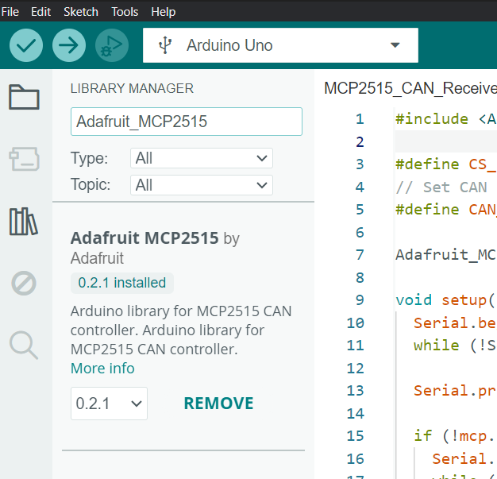
Library Installation:

Interfacing Arduino Uno with CAN Controller
Arduino Uno | CAN Controller
5V | VCC
GND | GND
Pin 10 | CS
Pin 11 | SI
Pin 12 | SO
Pin 13 | SCK

CAN Controller Tx | CAN Controller Rx
CAN H | CAN H
CAN L | CAN L

